BITS PILANI, DUBAI CAMPUS

DUBAI INTERNATIONAL ACADEMIC CITY, DUBAI

**FIRST SEMESTER 2024 – 2025 COURSE:** F213 (Object Oriented Programming)

**COMPONENT:** Lab 10 **DATE:** 6th November 2024

Q1. Implement this block in Java code

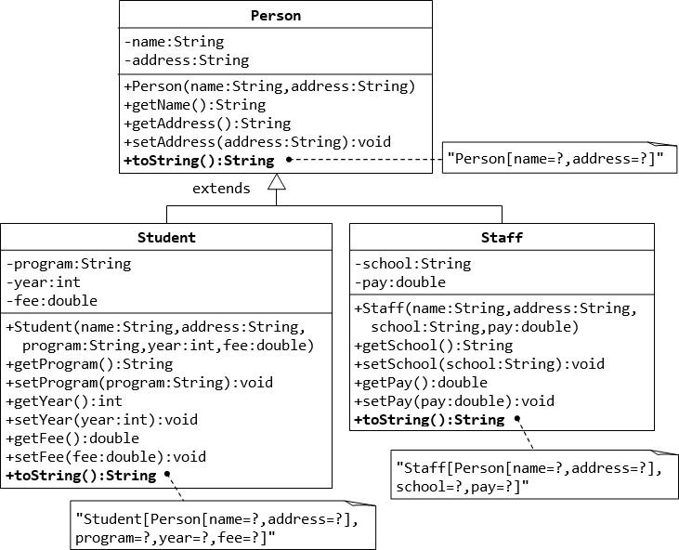

Q.2.

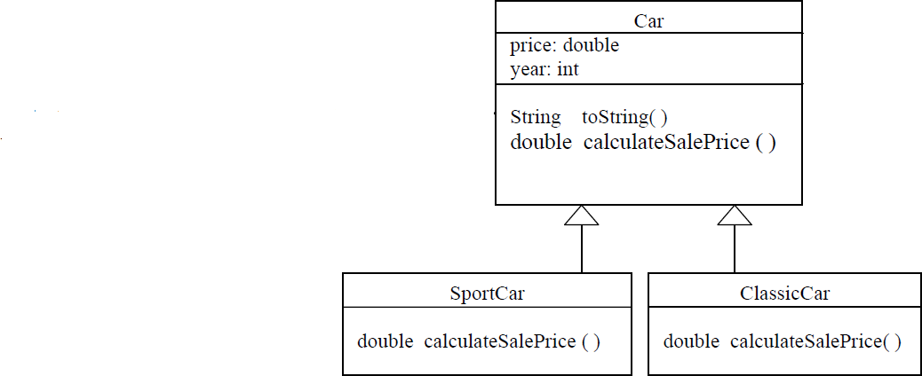

Write a Java class **Car** assuming it has this constructor:

# public Car(double price, int year)

and that the method **calculateSalePrice ( )**

Write a Java class **ClassicCar** assuming it has this constructor:

# public ClassicCar (double price, int year)

and that the method **calculateSalePrice ( )** returns 10,000 as the sale price of the car. Write a Java class **SportCar** assuming it has this constructor:

# public SportCar(double price, int year)

and that the method **calculateSalePrice ( )** calculates the sale price of the car as follow:

if year > 2000 then the sale price is 0.75 * its original price; if year > 1995 then the sale price is 0.5 * its original price; otherwise the sale price is 0.25 * its original price

Q.3 Write a superclass called Shape (as shown in the class diagram), which contains:

* Two instance variables color (String) and filled (boolean).
* Two constructors: a no-arg (no-argument) constructor that initializes the color to "green" and filled to true, and a constructor that initializes the color and filled to the given values.
* Getter and setter for all the instance variables. By convention, the getter for a boolean variable xxx is called isXXX() (instead of getXxx() for all the other types).
* A toString() method that returns "A Shape with color of xxx and filled/Not filled". Write a test program to test all the methods defined in Shape.

Write two subclasses of Shape called Circle and Rectangle, as shown in the class diagram. The Circle class contains:

* An instance variable radius (double).
* Three constructors as shown. The no-arg constructor initializes the radius to 1.0.
* Getter and setter for the instance variable radius.
* Methods getArea() and getPerimeter().
* Override the toString() method inherited, to return "A Circle with radius=xxx, which is a subclass of yyy", where yyy is the output of the toString() method from the superclass.

The Rectangle class contains:

* Two instance variables width (double) and length (double).
* Three constructors as shown. The no-arg constructor initializes the width and length to 1.0.
* Getter and setter for all the instance variables.
* Methods getArea() and getPerimeter().
* Override the toString() method inherited, to return "A Rectangle with width=xxx and length=zzz, which is a subclass of yyy", where yyy is the output of the toString() method from the superclass.

Write a class called Square, as a subclass of Rectangle. Convince yourself that Square can be modeled as a subclass of Rectangle. Square has no instance variable, but inherits the instance variables width and length from its superclass Rectangle.

